How to Update Your Current ACR Login Password

- Go to https://sso.acr.org and log in with your current ACR Login
- In the top right corner of your screen, click on your profile (your first name will be displayed) and select 'Settings'
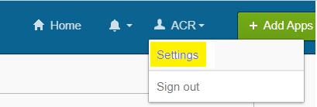
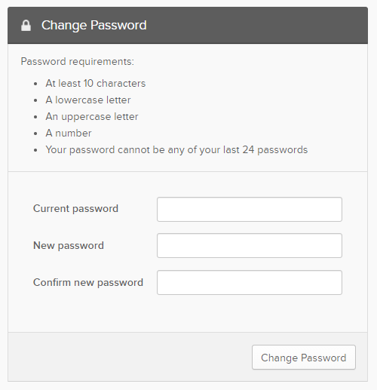

3. Enter your current password in the 'Current Password' field.
4. Next, based on the password requirements listed, create a new password. Enter this password in both the 'New password' and 'Confirm new password' fields
5. Click 'Change Password'

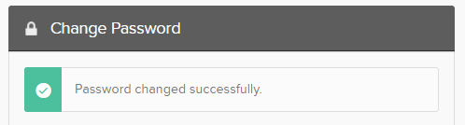
6. You will see the 'Password changed successfully' screen below.

Note: You do not need to update or change your email unless either you or the ACR suspect your account may have been compromised.

Questions? Contact: NRDRSupport@acr.org

