How to Reset a Forgotten Password

- From the ACR Login page (https://sso.acr.org) click 'Need help signing in?' to view the self-service options available.
- Select 'Forgot password?'
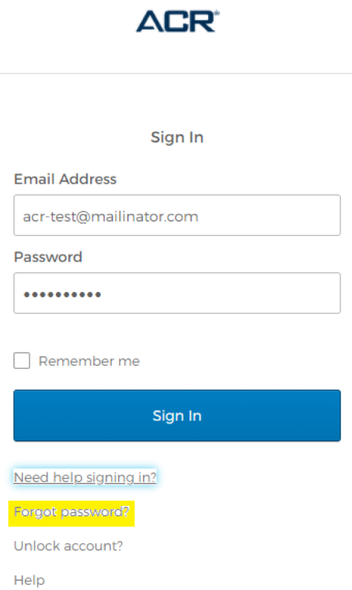

- Enter the email address used for your ACR Login and click 'Reset Email.’ This must be a valid, active email address that you can access.
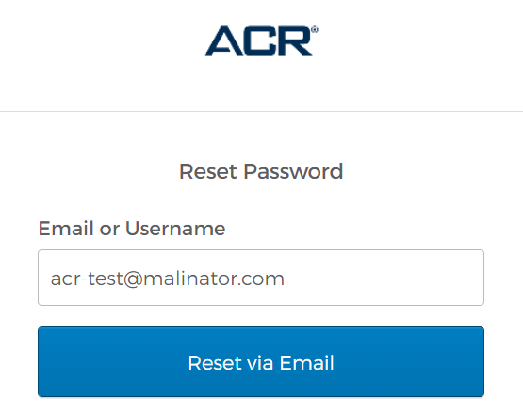

- If you have an active ACR Login, then you will receive the following email.
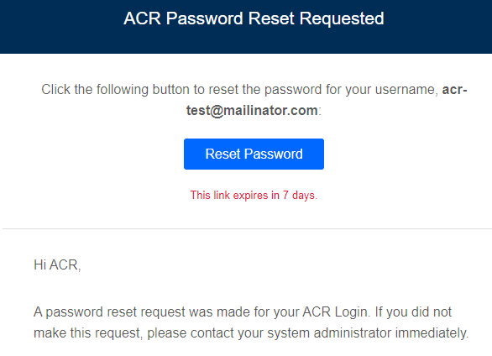
  - Click the 'Reset Password' button in the email.

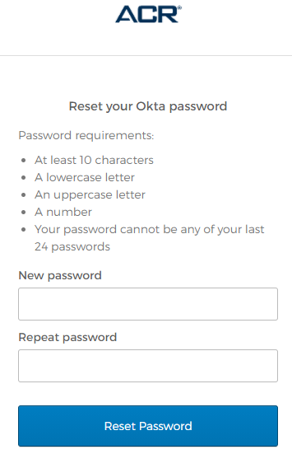
  - You will be taken to the screen as shown on the right and asked to create a new password based on the requirements shown.

- Enter your password in both the 'New password' and 'Repeat password' fields and click 'Reset Password.'
- If successful, you will be taken to your ACR Login dashboard where you can access your ACR applications.

Note: You do not need to update or change your email unless either you or the ACR suspect your account may have been compromised.

Questions? Contact NRDRSupport@acr.org

