How to Update your Email Address

- Go to https://sso.acr.org and log in with your current ACR Login
- In the top right corner of your screen, click on your profile (your first name will be displayed) and select 'Settings'
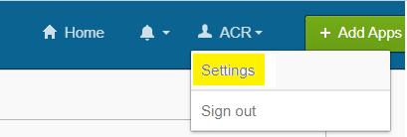

- Click 'Edit' in the Personal Information section
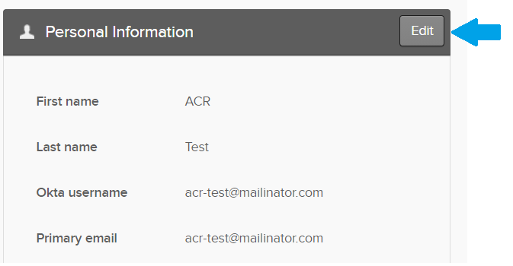

- If prompted, enter your ACR Login credentials.

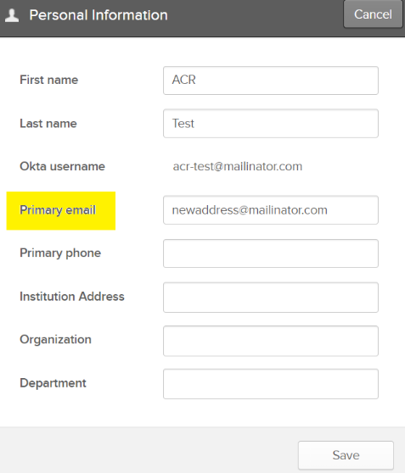

- Enter your new email address in the 'Primary email' field highlighted below. Click Save.

6. You will be presented the following message
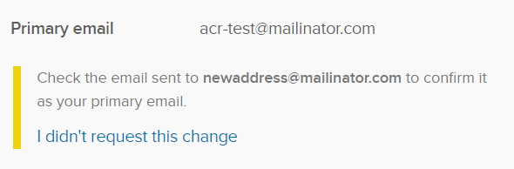
- Go to the Email account you entered in the 'Primary email field' and look for the email from 'ACR'. Click the 'Confirm Email Change' button.
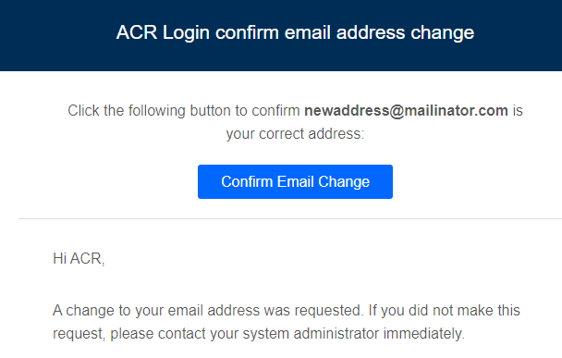

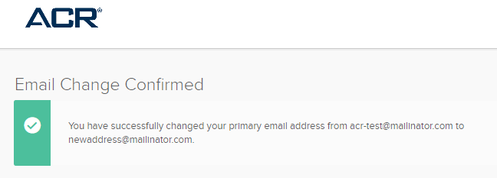
- You will receive a message that your email has successfully been updated.

Note: This is now both your primary email address, as well as your username. You must use this email address for your ACR Login going forward.

Questions? Contact NRDRSupport@acr.org

