How to Unlock Your Account

Your account becomes locked due to 5 or more failed login attempts (incorrect username and/ or password). All accounts automatically become unlocked after 30 minutes, but you may perform a self-service unlock by following these instructions.

- From the ACR Login page (https://sso.acr.org) click 'Need help signing in?' to view the self-service options available.
- Select 'Unlock account?'
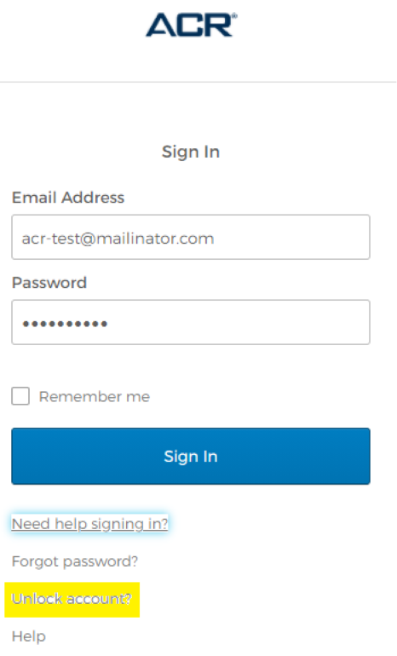
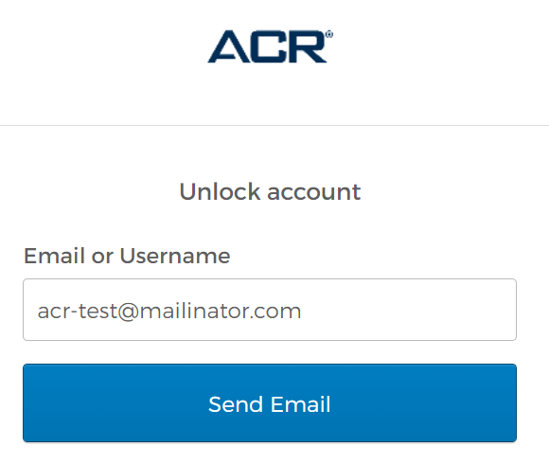
- Enter the email address used for your ACR Login and click 'Send Email'. This must be a valid, active email address that you can access.

- If your ACR Login was not locked out, you will receive the email shown in the screenshot below. If you are still having trouble logging in, perform a password reset by using the link in the email (https://sso.acr.org/signin/forgot-password).
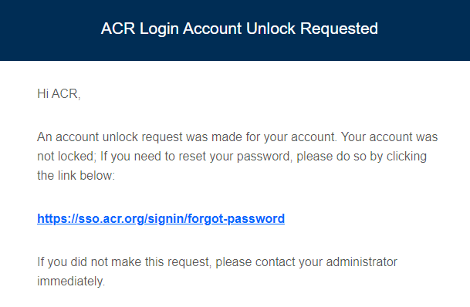

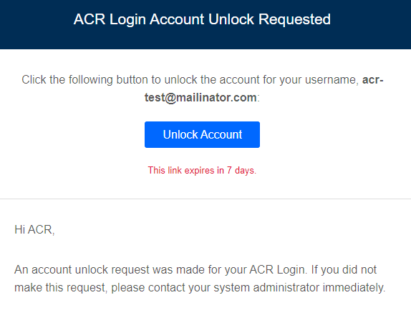
If your ACR Login was locked out due to 5 or more failed login attempts, you will receive the email as shown to the left.

- Click the 'Unlock Account' button in the email. If successful, you will see the screen below, and can now use your ACR Login.
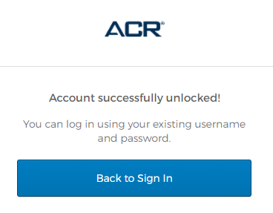
Note: These emails are only valid for 7 days and are one-time use.
If you miss the 7-day period, or attempt to use the email twice, you must start back at step 1.

Questions? Contact NRDRSupport@acr.org

